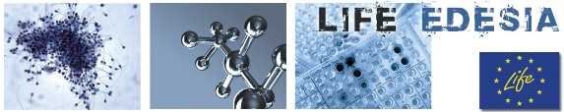
EFSA – IPAM day - 3rd LIFE-EDESIA workshop on
Endocrine Disruptors and alternative methods to animal testing –
a scientific and regulatory perspective

February 28th, 2018
Workshop venue: Parma, EFSA Room 00/M07, via Carlo Magno, 1A 43126 Parma PR, Italy

REGISTRATION FORM
to be submitted within Friday, February 23rd 2018 by e-mail to: stefano.lorenzetti@iss.it

Family name ………………………………………………………………………………………………………….
Name………………………………………………………………………………………………………………….
Title ………………………………………………………………………………………………………………….
Gender: Female Male
Birthplace …………………………………………………………………………………………………………….
Date of birth…………………………………………………………….…………………………………………….
Nationality ……………………………………………………………………………………………………………
Affiliation …………………………………………………………………………………………………………….
………………………………………………………………………………………………………………………...
Address ………………………………………………………………………………………………………………
………………………………………………………………………………………………………………………...
Phone …………………………………………………………………………...…………………………………….
E-mail 1 ………………………………………………………………………………………………………………
E-mail 2…………………………………………………………………………………………………….…………

Scientific Committee

Pietro COZZINI – University of Parma, Parma
Stefano LORENZETTI – LIFE-EDESIA project manager, IPAM secretariat, Istituto Superiore di Sanità (ISS), Rome

Isabella DE ANGELIS – IPAM President, Istituto Superiore di Sanità (ISS), Rome
Stylianos KOULOURIS – Engagement & Cooperation Unit, EFSA, Parma

Acknowledgements
The organization of the LIFE-EDESIA workshops are made possible by the support of the European Food Safety Authority (EFSA) and by the Italian Platform on Alternative Methods (IPAM; www.ipamitalia.org).
The event is organized within the frame of the After-Life communication activities of the LIFE-EDESIA project (LIFE12 ENV/IT/000633; www.iss.it/life; life.edesia@iss.it).
